**CAP 6675 Fall 2017 – Homework 3 Report**

**Last Updated: November 12, 2017**

**Due Sunday, November 12, 2017**

Jeff Hildebrandt, Md Saifuden, Josiah Wong

**Introduction**

This document describes the question, hypothesis, experiment, results, and conclusions from our modifications of the stigmergic ant colony model. In the unmodified, original model, ant agents randomly wander around in search for food. Once an ant finds food, it takes it back to the nest and emits a pheromone trail on its return path so that other ants can trace it to the food source. The pheromone dispersion and evaporation rates can be set by the original model. We investigated the effect of task allocation mechanisms on food retrieval efficiency.

**Investigation: Task Allocation**

*a. Question*

In a real ant colony, ant agents specialize in food foraging and brood care tasks. Thus, ants must continuously decide which task they will do, and the colony is better off if task allocation of all ants adapts to various stimuli. Task allocation in ants is affected by experience (Ravary et. al., 2007), and so our question is: “How do different changes in ant thresholds for performing certain tasks affect the ability of the colony to manage the balance between two tasks, foraging and brood care?”

*b. Hypothesis*

Given two tasks, an ant’s *threshold* is how much more likely it is to perform one task over another. We considered two factors: the threshold an ant is born with and how that threshold changes over time. Whatever these thresholds are, the best outcome for an ant colony is to allocate the fewest ants to each task that results in the greatest payoff from each task. In other words, the best outcome maximizes the payoff per ant. We hypothesize that a random initial threshold distribution over all ants and allowing experiences to change these thresholds at a flat rate over time will result in the maximum number of “points” gathered per ant. The rationale behind this hypothesis is that a random initial threshold scheme will make all the ants different and therefore specialize in varying degrees in either foraging or brood care. The flat rate threshold adaptation scheme will allow ants to choose their task according to food availability. If too few ants are foraging, then more ants that probabilistically try to forage will succeed, experience a decreased threshold for foraging, and continue to forage, increasing food input. If too many ants are foraging, then some will fail, experience an increased threshold for foraging, and fall back to brood care, increasing food per forager in both cases. A similar argument applies to brood care.

*c. Experiments*

We tested our hypothesis by implementing a NetLogo model of the stimergic ant colony where the top half of the view represents the outside world and the bottom half represents the interior of the nest. The nest has one entry/exit point from which there are paths into the nest or into the outside word that the ants can travel on. If an ant chooses to forage, it retrieves food from the outside world according to the original ant model (traveling only on the paths) and deposits it at the nest entrance. If an ant chooses to do brood care, it searches for food inside the nest and brings it back to the nest entrance/exit. In the real world, ants care for larvae when doing brood care (Locher et. al., 2009), but for simplicity, we implemented a secondary food searching task and called it “brood care”. If an ant does not find food after a certain amount of time, it gives up and returns to the nest entrance.

Upon returning to the nest, a successful forager increases its foraging points and decreases its brood points, and a successful brood worker increases its brood care points and decreases its foraging points. Increases in an ant’s foraging or brood points also contribute to colony foraging and brood sums, respectively, but unlike ant points, colony sums never decrease. (An ant that has given up on its task experiences no change in points and contributes nothing to colony totals.) After reaching the nest entrance, the ant probabilistically chooses its next task according to its task threshold. This threshold changes at a flat rate or a graduated rate (10 divided by total points ant has collected cumulatively). The threshold decreases if brood care was successfully attempted and increases if foraging was successfully attempted because both operations are inverses – being more inclined toward one task makes an ant less inclined toward the other.

For initial ant thresholds, we set thresholds of all ants to either 75% forage (and 25% brood care), a random percentage, and or 50% forage (and 50% brood care). For threshold change schemes, we experimented with no threshold change (thresholds remain the same throughout the simulation), flat change (thresholds change by a fixed amount after every task attempt), and graduated change (earlier experiences contribute more to threshold changes than later experiences). For each threshold initialization/change scheme combination, we measured final colony foraging points, final colony brood care points, average food retrieved per forager ant over time (from both foraging and brood care), average percentage of ants that have more experience in foraging, and average percentage of foraging done by forager ants. For all experiments, we used an ant population of 139. Also, in all experiments, the nest-size is 35 (half of the 70 x 70 view), the maximum number of time steps before an ant “gives up” on its current task is 500, the food amount is 1000, and the return-speed of ants to the nest entrance/exit is 2. Chemical evaporation rate is 3.

We repeated this experiment for three maps to vary the relative difficulty of brood care and foraging. All maps contain three paths into the foraging area and three paths into the nest interior. The end of each path contains an approximately equal amount of food. All nest paths are equal in length and all foraging paths are equal in length. Green paths are for foraging, brown paths are for brood care. The nest entrance/exit is the purple disk.

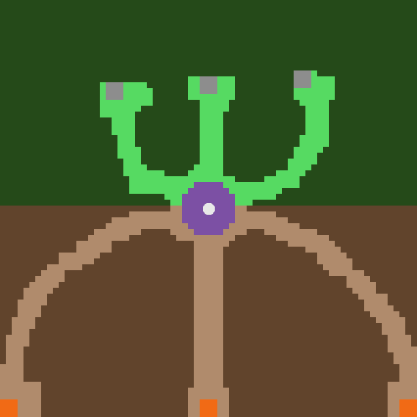 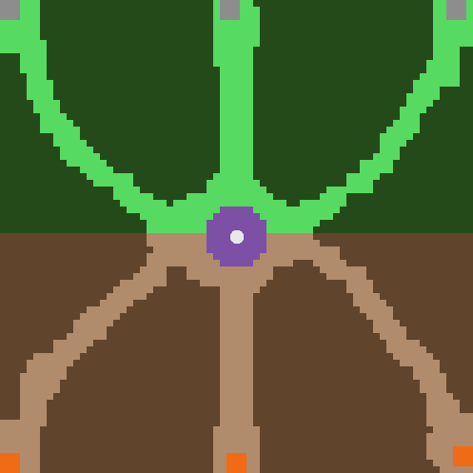 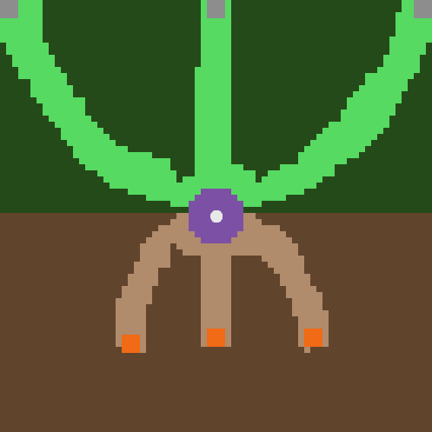

Figure 1 Easy forage map Figure 2 Neutral forage map Figure 3 Hard forage map

The first map (Figure 1) contains short foraging paths and longer nest paths, making foraging an easier task than brood care. The second map (Figure 2) contains foraging paths that are equal in length to the nest paths, so the brood care and foraging tasks are approximately equal in difficulty. The third map (Figure 3) contains foraging paths that are longer than the nest paths, making foraging the harder task.

The hypothesis is confirmed if random initial threshold and a flat threshold change scheme resulted in the highest food per ant cumulative value for all three maps.

*d. Results*

Tables 1-3 show the results on maps 1-3, respectively, of each combination of threshold initialization and threshold change scheme. The best performing combination in terms of average final ant points is highlighted in yellow. The second and third place combinations are highlighted in orange. It should be noted that imprecision in map generation resulted in the hard foraging map having thicker paths, allowing ants to collect more food overall in both tasks.

Table 1 Map 1 - Foraging is easier than brood care

|  |  |  |  |  |  |  |
| --- | --- | --- | --- | --- | --- | --- |
| Initial Foraging Threshold | Threshold Change Scheme | Final colony foraging points | Final colony brood care pts | Avg. ant points, both tasks | Avg. % ants that are foragers | Avg. % foraging done by forager ants |
| 75% forage | No change | 565 | 1370 | 13.91 | 15.07 | 33.88 |
| 75% forage | Flat change | 818 | 1527 | 16.86 | 19.78 | 31.06 |
| 75% forage | Graduated change | 758 | 1248 | 14.42 | 17.8 | 30.53 |
| Random % forage | No change | 1600 | 977 | 18.53 | 36.01 | 79.42 |
| Random % forage | Flat change | 1586 | 1453 | 21.85 | 29.71 | 60.6 |
| Random % forage | Graduated change | 1300 | 1268 | 18.46 | 23.85 | 60.78 |
| 50% forage | No change | 1274 | 1186 | 17.68 | 27.77 | 59.17 |
| 50% forage | Flat change | 1397 | 1302 | 19.4 | 25.88 | 52.49 |
| 50% forage | Graduated change | 1100 | 1073 | 15.62 | 26.45 | 50.08 |

Table 2 Map 2 - Foraging and brood care are equally difficult

|  |  |  |  |  |  |  |
| --- | --- | --- | --- | --- | --- | --- |
| Initial Foraging Threshold | Threshold Change Scheme | Final colony foraging points | Final colony brood care pts | Avg. ant points, both tasks | Avg. % ants that are foragers | Avg. % foraging done by forager ants |
| 75% forage | No change | 420 | 1224 | 11.81 | 26.15 | 18.76 |
| 75% forage | Flat change | 683 | 1120 | 12.96 | 32.56 | 25.29 |
| 75% forage | Graduated change | 558 | 1071 | 11.71 | 33.72 | 16.19 |
| Random % forage | No change | 1066 | 911 | 14.21 | 50.6 | 65.82 |
| Random % forage | Flat change | 973 | 906 | 13.5 | 48.84 | 59.61 |
| Random % forage | Graduated change | 981 | 887 | 13.42 | 46.84 | 56.29 |
| 50% forage | No change | 904 | 841 | 12.54 | 49.85 | 45.21 |
| 50% forage | Flat change | 952 | 937 | 13.58 | 49.7 | 46.51 |
| 50% forage | Graduated change | 744 | 828 | 11.29 | 50.14 | 39.38 |

Table 3 Map 3 - Foraging is harder than brood care

|  |  |  |  |  |  |  |
| --- | --- | --- | --- | --- | --- | --- |
| Initial Foraging Threshold | Threshold Change Scheme | Final colony foraging points | Final colony brood care pts | Avg. ant points, both tasks | Avg. % ants that are foragers | Avg. % foraging done by forager ants |
| 75% forage | No change | 920 | 2807 | 27.17 | 51.5 | 10.08 |
| 75% forage | Flat change | 1495 | 2363 | 27.74 | 57.87 | 12.57 |
| 75% forage | Graduated change | 1313 | 2199 | 25.25 | 59.6 | 12.3 |
| Random % forage | No change | 1683 | 2138 | 27.47 | 64.21 | 57.25 |
| Random % forage | Flat change | 1537 | 1713 | 23.37 | 67.78 | 37.51 |
| Random % forage | Graduated change | 1980 | 1990 | 28.55 | 69.24 | 49.47 |
| 50% forage | No change | 1246 | 1314 | 18.4 | 74.29 | 33.47 |
| 50% forage | Flat change | 1488 | 1499 | 21.47 | 69.32 | 38.54 |
| 50% forage | Graduated change | 1345 | 1420 | 19.88 | 68.45 | 33.24 |

*e. Conclusions*

Based on our results, our hypothesis was not confirmed. We thought a random initial threshold distribution over a flat rate would result in the highest amount of food collected per ant. However, this was true only when foraging was easier than brood care. We believe this is caused by the random distribution of initial thresholds just happening to favor creation of foraging threshold ants. There is evidence of this since the opposite happened in the foraging-is-harder-than-brood-care map and those results should have been the same, likely because the random distribution once again favored creation of foraging threshold ants.

There were some observations during our experiment that are of note. Namely, during the maps when foraging or brooding was easier, a higher number of ants would be in the more difficult section. This is because after every time an ant collected food, it returned to the nest entrance to be reassigned. When the ants were in the easier section, they would return more often and have a chance to be assigned to the harder section. This happened often and resulted in more ants always being in the harder section since it would take longer for them to return to the nest entrance. This acted as a natural equalizer on non-equal maps, if the starting threshold was random or 50%. This is proven by looking at the relatively equal brood points and forage points in non-equal maps. Another observation of note is that graduated change would consistently underperform when compared to a flat rate of change. This could be attributed to gradual change not being as dynamic as the flat change. If an ant during the gradual change threshold was assigned to the more difficult side, it was more likely to stay there, resulting in the ant not exploiting the side where food was easier to collect. Whereas with the flat rate, an ant is equally likely to go to either side in the beginning stages, and is more likely to specialize in the easier side.

There were a couple fallacies in how we collected data that somewhat skewed results. First, the random initialization of forage thresholds was too random. The ants could be greatly affected by how high their initial threshold was based on the random effect. The effect is also magnified by the small number of ants that we experimented with. Having a standard deviation over a large number of experiments would have evened out the results. Also, Map 3 (where foraging is harder than brood care) had a larger final points-per-ant percentage. This was due to Map 3 having wider lanes than the other two maps. The smaller lanes created a bottleneck where the ants were not able to pass through as quickly.

The contributions of this study are as follows. First, we have shown that the more difficult one task is relative to another task, the more ants that tend to be allocated toward that task, as can be seen by the increased percentage of foragers for maps where foraging was increasingly more difficult than brood care. This is because ants finish the easier task first, then probabilistically switch to the other task after experiencing failure and returning to the nest entrance less quickly. Second, we have shown that in the absence of threshold changes as a result of experience, the initial assignment of thresholds is the sole determinant of the division of labor. In our study, the combination of no threshold changes and random initialization of thresholds resulted in top performance in each map. Thus, we contribute the knowledge that random initialization of task thresholds by itself can result in sufficient specialization of ants to accomplish two inverse tasks. Finally, we show that graduated threshold changes resulted in top performance fewer times than flat threshold changes. This is because graduated threshold changes in general do not allow ants to adapt quickly enough to discovered opportunities to contribute to colony sums that arise over time because of ants discovering new food sources. Ultimately, we show that even though random initialization of thresholds and flat changes in threshold due to experience are advantageous, there are more factors to consider in finding optimal divisions of labor in a binary task situation.

**References**

Locher, G. D. A., Giannotti, E., & Tofolo, V. C. (2009). Brood care behavior in Ectatomma brunneum (hymenoptera, formicidae, ectatomminae) under laboratory conditions. *Sociobiology*, *54*(2), 573–587.

Ravary, F., Lecoutey, E., Kaminski, G., Châline, N., & Jaisson, P. (2007). Individual Experience Alone Can Generate Lasting Division of Labor in Ants. *Current Biology*, *17*(15), 1308–1312.